**ARITHMETIC OPERATOR CALCULATOR**

**CODE:**

//WRITTEN BY ALFIYA SHAIKH

<!DOCTYPE html>

<html lang="en">

<head>

<meta charset="UTF-8">

<title>Enhanced Colorful Calculator</title>

<style>

body {

background: linear-gradient(to right, #ffecd2, #fcb69f);

font-family: 'Segoe UI', sans-serif;

display: flex;

justify-content: center;

align-items: center;

height: 100vh;

margin: 0;

}

.calculator {

background-color: #ffe4e1;

padding: 20px;

border-radius: 15px;

box-shadow: 0 8px 16px rgba(0,0,0,0.2);

width: 320px;

display: flex;

flex-direction: column;

align-items: center;

}

.title {

font-size: 24px;

font-weight: bold;

margin-bottom: 10px;

color: #333;

text-shadow: 1px 1px #fff;

}

.display {

width: 100%;

height: 50px;

font-size: 24px;

text-align: right;

padding: 10px;

border: none;

border-radius: 10px;

margin-bottom: 15px;

background-color: #f0f0f0;

}

.buttons {

display: grid;

grid-template-columns: repeat(4, 1fr);

gap: 10px;

width: 100%;

}

button {

padding: 15px;

font-size: 18px;

border: none;

border-radius: 10px;

cursor: pointer;

transition: background-color 0.3s;

}

button:hover {

background-color: #ddd;

}

.operator {

background-color: #ff9a9e;

}

.number {

background-color: #a1c4fd;

}

.equal {

background-color: #c2ffd8;

grid-column: span 2;

}

.clear {

background-color: #fbc2eb;

grid-column: span 2;

}

.footer {

margin-top: 15px;

font-size: 14px;

color: #555;

font-style: italic;

}

</style>

</head>

<body>

<div class="calculator">

<div class="title">Arithmetic Operator</div>

<input type="text" class="display" id="display" disabled>

<div class="buttons">

<button class="number" onclick="append('7')">7</button>

<button class="number" onclick="append('8')">8</button>

<button class="number" onclick="append('9')">9</button>

<button class="operator" onclick="append('/')">÷</button>

<button class="number" onclick="append('4')">4</button>

<button class="number" onclick="append('5')">5</button>

<button class="number" onclick="append('6')">6</button>

<button class="operator" onclick="append('*')">×</button>

<button class="number" onclick="append('1')">1</button>

<button class="number" onclick="append('2')">2</button>

<button class="number" onclick="append('3')">3</button>

<button class="operator" onclick="append('-')">−</button>

<button class="number" onclick="append('0')">0</button>

<button class="number" onclick="append('.')">.</button>

<button class="operator" onclick="append('%')">%</button>

<button class="operator" onclick="append('+')">+</button>

<button class="operator" onclick="append('^')">**</button>

<button class="operator" onclick="append('++')">++</button>

<button class="operator" onclick="append('--')">--</button>

<button class="clear" onclick="clearDisplay()">C</button>

<button class="equal" onclick="calculate()">=</button>

</div>

<div class="footer">Designed by ALFIYA SHAIKH</div>

</div>

<script>

const display = document.getElementById('display');

function append(value) {

display.value += value;

}

function clearDisplay() {

display.value = '';

}

function calculate() {

let expression = display.value;

if (expression.includes('^')) {

const parts = expression.split('^');

if (parts.length === 2) {

const base = parseFloat(parts[0]);

const exponent = parseFloat(parts[1]);

display.value = Math.pow(base, exponent);

return;

} else {

display.value = 'Error';

return;

}

}

if (expression.includes('++')) {

const num = parseFloat(expression.replace('++', ''));

display.value = num + 1;

return;

}

if (expression.includes('--')) {

const num = parseFloat(expression.replace('--', ''));

display.value = num - 1;

return;

}

try {

display.value = eval(expression);

} catch {

display.value = 'Error';

}

</script>

</body>

</html>

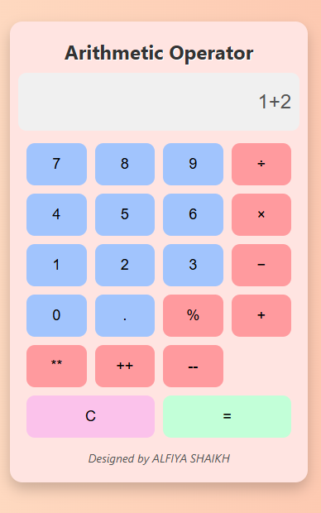

**MULTI-FUNCTION CALCULATOR**

**CODE:**

//WRITTEN BY ALFIYA SHAIKH

<!DOCTYPE html>

<html lang="en">

<head>

<meta charset="UTF-8">

<title>Pastel Calculator with Reverse & Prime</title>

<link href="https://fonts.googleapis.com/css2?family=Quicksand:wght@400;600&display=swap" rel="stylesheet">

<style>

body {

background: linear-gradient(to right, #fbc2eb, #a6c1ee);

font-family: 'Quicksand', sans-serif;

display: flex;

justify-content: center;

align-items: center;

height: 100vh;

margin: 0;

}

.calculator {

background-color: #fffafc;

padding: 30px;

border-radius: 25px;

box-shadow: 0 8px 20px rgba(0, 0, 0, 0.1);

width: 360px;

display: flex;

flex-direction: column;

align-items: center;

}

.title {

font-size: 28px;

font-weight: 600;

margin-bottom: 20px;

color: #6b5b95;

}

.display {

width: 100%;

height: 60px;

font-size: 26px;

text-align: right;

padding: 12px;

border: none;

border-radius: 15px;

margin-bottom: 20px;

background-color: #f3f3f3;

color: #333;

box-shadow: inset 0 2px 5px rgba(0,0,0,0.05);

}

.buttons {

display: grid;

grid-template-columns: repeat(4, 1fr);

gap: 14px;

width: 100%;

}

button {

padding: 16px;

font-size: 18px;

border: none;

border-radius: 12px;

cursor: pointer;

transition: background-color 0.3s, transform 0.2s;

color: #333;

font-weight: 600;

}

button:hover {

background-color: #eaeaea;

transform: scale(1.05);

}

.number { background-color: #cde7f0; }

.operator { background-color: #f7c5cc; }

.equal { background-color: #c1f0d6; grid-column: span 2; }

.clear { background-color: #ffe5b4; grid-column: span 2; }

.special { background-color: #d5c1f0; grid-column: span 2; }

.footer {

margin-top: 25px;

padding: 8px 16px;

background-color: #ffe5b4;

color: #333;

font-size: 14px;

font-weight: bold;

font-style: italic;

border-radius: 12px;

box-shadow: 0 2px 6px rgba(0,0,0,0.1);

transition: all 0.3s ease;

text-align: center;

}

.footer:hover {

background-color: #ffd8a8;

box-shadow: 0 4px 12px rgba(0,0,0,0.2);

transform: scale(1.05);

}

</style>

</head>

<body>

<div class="calculator">

<div class="title">Multi – Function Calculator</div>

<input type="text" class="display" id="display" disabled>

<div class="buttons">

<button class="number" onclick="append('7')">7</button>

<button class="number" onclick="append('8')">8</button>

<button class="number" onclick="append('9')">9</button>

<button class="operator" onclick="append('+=')">+=</button>

<button class="number" onclick="append('4')">4</button>

<button class="number" onclick="append('5')">5</button>

<button class="number" onclick="append('6')">6</button>

<button class="operator" onclick="append('-=')">-=</button>

<button class="number" onclick="append('1')">1</button>

<button class="number" onclick="append('2')">2</button>

<button class="number" onclick="append('3')">3</button>

<button class="operator" onclick="append('*=')">*=</button>

<button class="number" onclick="append('0')">0</button>

<button class="number" onclick="append('.')">.</button>

<button class="operator" onclick="append('%=')">%=</button>

<button class="operator" onclick="append('/=')">/=</button>

<button class="clear" onclick="clearDisplay()">C</button>

<button class="equal" onclick="calculate()">=</button>

<button class="special" onclick="reverseNumber()">Reverse</button>

<button class="special" onclick="checkPrime()">Prime?</button>

</div>

<div class="footer">Designed by ALFIYA SHAIKH</div>

</div>

<script>

const display = document.getElementById('display');

function append(value) {

display.value += value;

}

function clearDisplay() {

display.value = '';

}

function calculate() {

let expression = display.value;

let result;

if (expression.includes('+=')) {

const parts = expression.split('+=');

result = parseFloat(parts[0]) + parseFloat(parts[1]);

} else if (expression.includes('-=')) {

const parts = expression.split('-=');

result = parseFloat(parts[0]) - parseFloat(parts[1]);

} else if (expression.includes('*=')) {

const parts = expression.split('*=');

result = parseFloat(parts[0]) * parseFloat(parts[1]);

} else if (expression.includes('/=')) {

const parts = expression.split('/=');

result = parseFloat(parts[0]) / parseFloat(parts[1]);

} else if (expression.includes('%=')) {

const parts = expression.split('%=');

result = parseFloat(parts[0]) % parseFloat(parts[1]);

} else {

result = 'Error';

}

display.value = isNaN(result) ? 'Error' : result;

}

function reverseNumber() {

const input = display.value;

if (!isNaN(input)) {

display.value = input.split('').reverse().join('');

} else {

display.value = 'Error';

}

}

function checkPrime() {

const num = parseInt(display.value);

if (isNaN(num) || num < 1) {

display.value = 'Invalid';

return;

}

if (num === 1) {

display.value = 'Not Prime';

return;

}

for (let i = 2; i <= Math.sqrt(num); i++) {

if (num % i === 0) {

display.value = 'Not Prime';

return;

}

}

display.value = 'Prime';

}

</script>

</body>

</html>

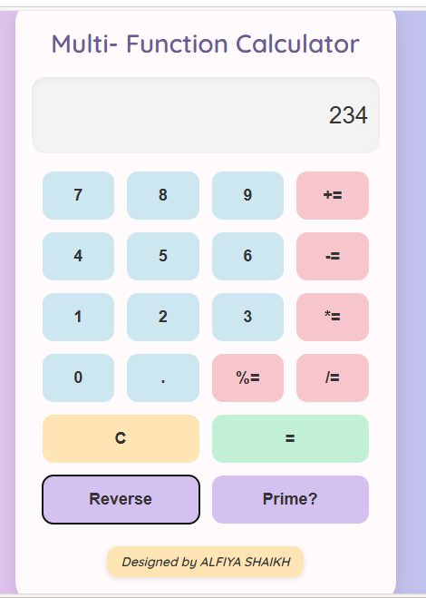

**ODD NUMBERS FROM 1 TO 200**

**CODE:**

//WRITTEN BY ALFIYA SHAIKH

<!DOCTYPE html>

<html lang="en">

<head>

<meta charset="UTF-8">

<title>Odd Numbers</title>

<style>

body {

font-family: 'Segoe UI', sans-serif;

background-color: #f0f8ff;

padding: 40px;

text-align: center;

}

h1 {

color: #333;

}

input {

padding: 10px;

margin: 10px;

width: 100px;

font-size: 16px;

}

button {

padding: 10px 20px;

font-size: 16px;

background-color: #4CAF50;

color: white;

border: none;

border-radius: 5px;

cursor: pointer;

}

button:hover {

background-color: #45a049;

}

.output {

margin-top: 30px;

display: flex;

flex-wrap: wrap;

gap: 10px;

justify-content: center;

}

.odd {

background-color: #ff6347;

color: white;

padding: 8px 12px;

border-radius: 6px;

box-shadow: 0 2px 5px rgba(0,0,0,0.1);

}

</style>

</head>

<body>

<h1>Odd Numbers </h1>

<p>Enter a range to find odd numbers:</p>

<input type="number" id="start" placeholder="Start">

<input type="number" id="end" placeholder="End">

<button onclick="showOddNumbers()">Show Odds</button>

<div class="output" id="output"></div>

<script>

function showOddNumbers() {

const start = parseInt(document.getElementById('start').value);

const end = parseInt(document.getElementById('end').value);

const output = document.getElementById('output');

output.innerHTML = '';

if (isNaN(start) || isNaN(end) || start > end) {

output.innerHTML = '<p>Please enter a valid range.</p>';

return;

}

for (let i = start; i <= end; i++) {

if (i % 2 !== 0) {

const span = document.createElement('span');

span.className = 'odd';

span.textContent = i;

output.appendChild(span);

}

}

}

</script>

</body>

</html>

